SPRINT-4

Date | 11 November 2022
TEAM ID | PNT2022TMID04063
Project Name | IoT Based smart crop Protection system for agriculture
Maximum mark | 20 marks

STEP 1: MIT APP inventor to design the APP.
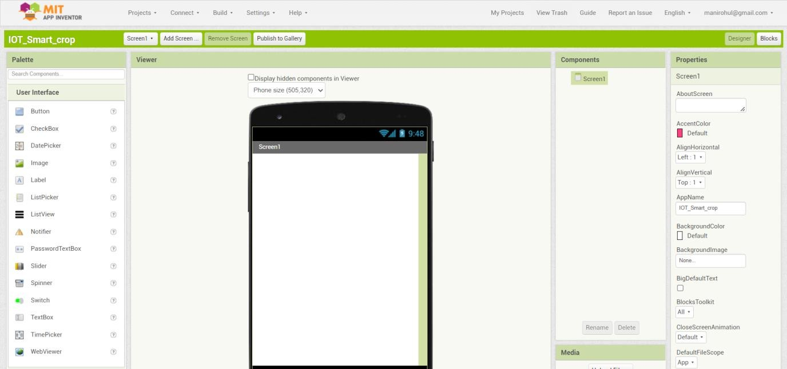

STEP 2: Customize the App interface to Display the Values.
